

Warrigal Road State School

314 Warrigal Road, Eight Mile Plains QLD 4113

PH: (07) 3340 5333

Warrigal Road State School Retailer Buying Sheet

Message from Warrigal Road State School to the retailer: Australian Consumer Law (ACL) guarantees that the laptop that you will sell to the buyer will be fit for purpose:

The purpose required for the laptop is to run the Warrigal Road State School BYOD educational platform which has strict minimum requirements.

The minimum requirements are located on Page 2.

Thankyou for your assistance.

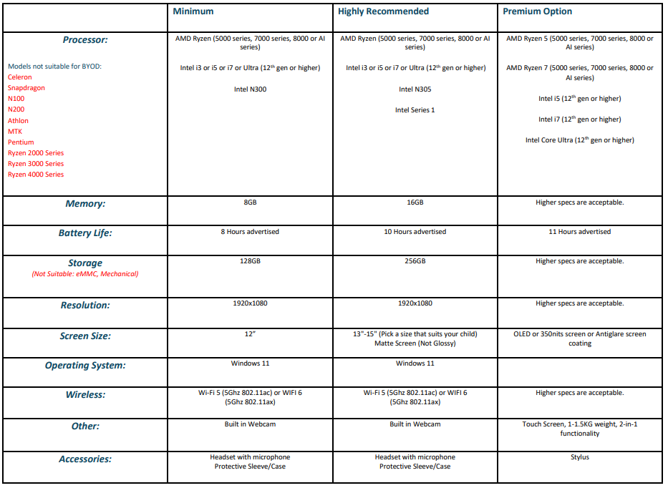

Incompatible Software: All Antivirus, security software and safety software that is not Microsoft (Norton, Mcafee, Trend Micro, AVG)

Do not purchase these Antivirus as they are not necessary.

Software provided for free from the school: Microsoft Office

